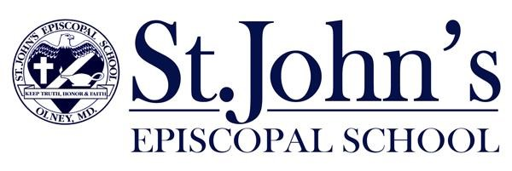

Transcript Release Form

To the Parents of the Applicant:

Please fill out this form and present it to the head or registrar of your child’s current school.

Student Name: ____________________________________________________________

First Middle Last

Grade this year: _______________________

Applying for grade: ____________________

I request and authorize the release of school and health records, including a complete transcript and results of any standardized tests, to St. John’s Episcopal School. I understand that the records are confidential.

______________________________________________ ___________________

Parent’s Signature Date

To The School Head or Registrar:

The student named above has made application for admission to St. John’s Episcopal School. To help us evaluate this student, would you please forward the above requested transcript, test results, and other pertinent records to us. Thank you for your assistance.

Please email to:
Lee Winter, Admissions and Enrollment
St. John’s Episcopal School
3427 Olney-Laytonsville Road
Olney, MD 20832

Phone: 301-774-6804 ext. 160
lee.winter@stjes.org
www.stjes.org

